ASSIGNMENTS

1. **LINKEDIN PROFILE**

URL:<https://www.linkedin.com/in/bakiyalakshmi-r-3a3121289>

1. **BRAND LOGO AND BRAND NAME PROMOTION ON FACEBOOK**

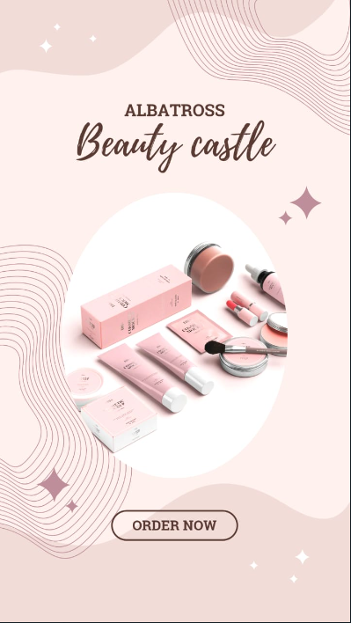

BRAND LOGO

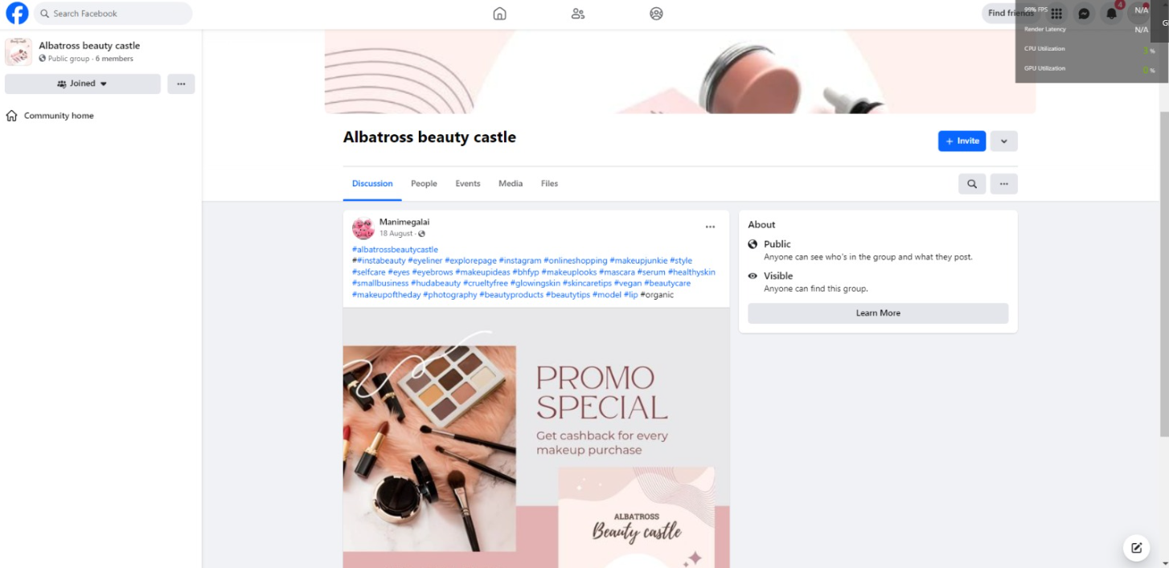

BRAND NAME PROMOTION ON FACEBOOK

1. **BLOGGER WEBSITE**

URL: <https://sarahfaradise.blogspot.com/?m=1>

1. **EMAIL NEWSLETTER**

URL: [https://sarahfaradise.blogspot.com/2023/09/email-news-letter-new-collection.html loration.html](https://saranarayanan03.blogspot.com/2023/09/emailnewsletterstourismexploration.ht)

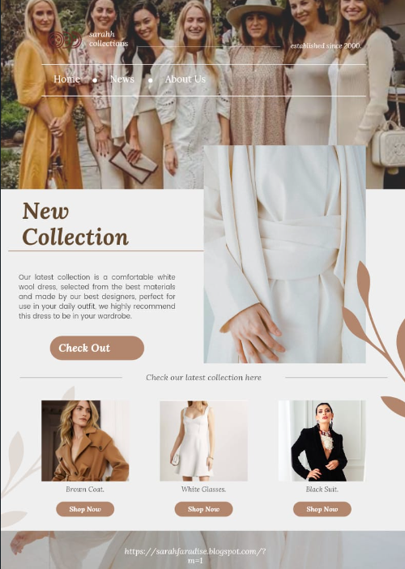

1. **INFOGRAPHICS**

URL : <https://sarahfaradise.blogspot.com/2023/09/top-5-healthiest-fruits-to-eat.html>

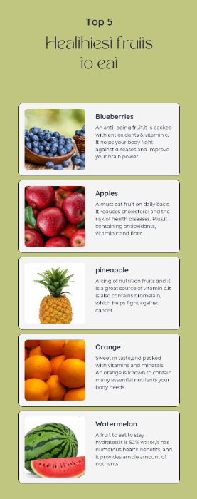

1. ARTICLE

URL: <https://sarahfaradise.blogspot.com/2023/10/articles-punctuality.html>

